**Computer Networks Lab (CL307)**

**Lab Session 02**

Date: 2/5/2020 Student ID: 17K-3795 Name: Muhammad Mustafa Manga

**Answer the Following Questions**

Q 1: Explain in one line

1. **Broadcast message:** Send message to all connected user at once (One to Many transmission).
2. **Unicast message:** One sender and receiver (One to One transmission).
3. **Multicast:** Send message only intended user at once (One to Many or Many to Many transmission).

Q 2: Hub is layer **ONE** device.

Q3: Switch is layer **TWO** device and it able to understand **MAC** addresses.

Q4: Router is layer **THREE** device and it use **IP** addresses.

Q 5: Switches has **THREE** number of modes, their names and commands are

1. **Default – No command**
2. **Privilege -- Enable**
3. **Global -- Config**

Q 6: If someone wants to configure switch what mode he/she should be use? And why?

Answer:  **Global because it allows all functions and operations to configure.**

Q7: Which command is used to check switch configuration?

Answer: **show interfaces.**

Q8: What is ICMP message?

Answer: **Internet Control Message Protocol. Information is transferred over the internet, computer systems send and receive data using the TCP/IP protocol.**

Q9: As in above task (activity number 3) when we send PDU from PC0 to PC1 it use source and destination IP addresses, same as when we ping from PC0 to PC1 by using IP addresses, As we can see PC0 and PC1 are connected with each other via Hub (layer 1 device) that is not able to understand IP. So how ICMP messages or ping messages has been sent?

Answer: **The hub contains multiple ports. When a packet arrives at one port, it is copied to the other ports so that all segments of the LAN can see all packets.**

Q10: Explain Inbound and Outbound.

Answer:

**Outbound:** The traffic starts flowing outward of your computer to the destination you intended.

**Inbound:** The traffic starts flowing inward to your computer or machine. 

**Q1(2):**

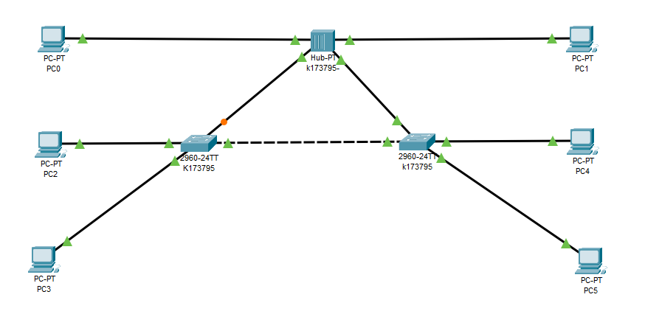

**Q1(3-1):**

::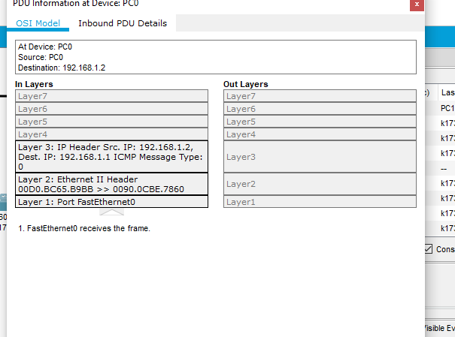

**Q1(3-2):**

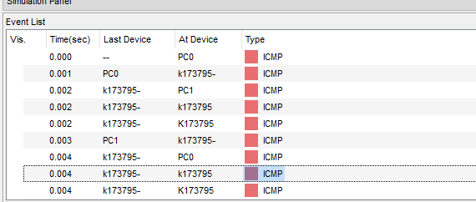

**Q1(4-1):**

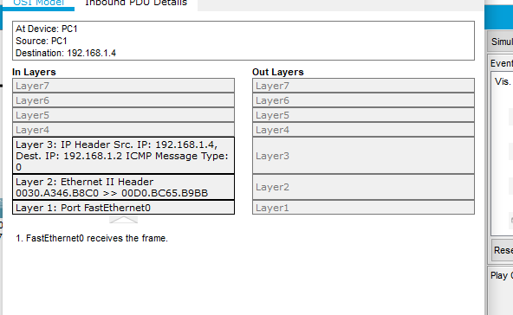

**Q1(4-2):**

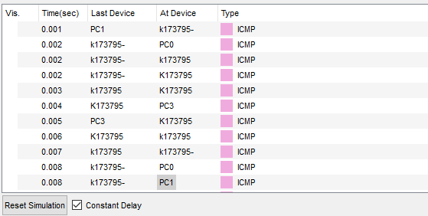

**Q1(5-1):**

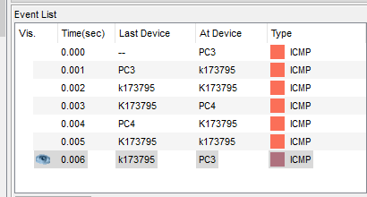

**Q1(5-2):**

